Features and traits of very large and strong typhoon (Trami)■

Typhoon Trami, now situated to the south of Okinawa, is very large and strong. It is heading north and expected to approach Okinawa sometime on 29th (Saturday), while considerably retaining its current strength. Following this, Typhoon Trami will likely change path to the northeast, threatening to cross from Kyushu through Hokkaido between 30th (Sunday) and October 1st (Monday).

The features of this typhoon are

· Slow movement in the vicinity of Okinawa, with prolonged influence
· Moist air around the typhoon will flow in to stimulate the seasonal rain front near Honshu into activity, increasing risk of heavy rain from the typhoon before she approaches.
· Typhoon Trami will likely to change its direction to northeast, then speed up at a stretch which could traverse Japan from Kyushu to Hokkaido, possibly becoming stronger without warning.

Features and traits of very large and strong typhoon (Trami)■

Typhoon Trami, now situated to the south of Okinawa, is very large and strong. It is heading north and expected to approach Okinawa sometime on 29th (Saturday), while considerably retaining its current strength. Following this, Typhoon Trami will likely change path to the northeast, threatening to cross from Kyushu through Hokkaido between 30th (Sunday) and October 1st (Monday).

The features of this typhoon are
· Slow movement in the vicinity of Okinawa, with prolonged influence
· Moist air around the typhoon will flow in to stimulate the seasonal rain front near Honshu into activity, increasing risk of heavy rain from the typhoon before she approaches.

· Typhoon Trami will likely to change its direction to northeast, then speed up at a stretch which could traverse Japan from Kyushu to Hokkaido, possibly becoming stronger without warning.

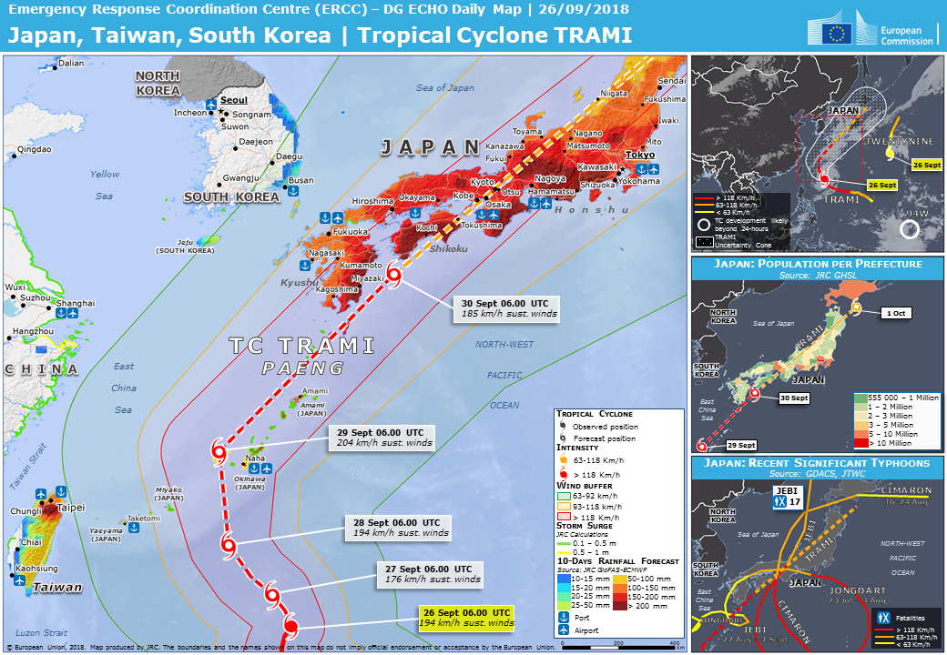

■Precautions required in various areas■

【Okinawa】
In Okinawa the wind is strong and the sea becomes rough. The wind will further strengthen on 27th (Thursday), the ocean will get rougher with swells. After 28th, conditions are expected to become fierce. On islands such as Ishigakijima, the main region will be stormy from 28th (Friday) through 29th (Saturday). Strong vigilance is required for high waves and storm surges. Attention should also be paid as to inundation and flooding near the coast.

【Kyushu - Kinki】
On 29th (Saturday), activities of the seasonal rain front will become active, with developing rain clouds following successively. There is a danger of the amount of rain increasing from before the typhoon approaches. If the typhoon advances into the center of the forecast circle, it will traverse west Japan on 30th (Sunday) and the typhoon body's active rain clouds may hit the region. There is a possibility that transportation will be greatly hampered, so attention is needed.

【Tokai - Kanto】
From 29th (Saturday), active rain clouds will hit under the influence of the stimulated seasonal rain front. As the typhoon moves through the center of the forecast circle, rain and wind will intensify around the morning of 30th (Sunday) through that of October 1st (Monday) and could produce rough conditions.

【Tohoku / Hokkaido】
For now, stormy weather is expected on October 1st (Monday). Typhoon is expected to increase speed near Honshu, so there is a possibility that it will approach northern Japan. Please be prepared.

